15.70: a) The wave moving to the left is inverted and reflected; the reflection means that the wave moving to the left is the same function of 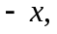and the inversion means that the function is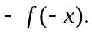More rigorously, the wave moving to the left in Fig. (15.17) is obtained from the wave moving to the right by a rotation of 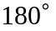, so both the coordinates 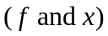have their signs changed. b). The wave that is the sum is 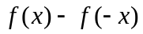 (an inherently odd function), and for any 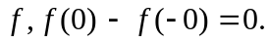 c) The wave is reflected but not inverted (see the discussion in part (a) above), so the wave moving to the left in Fig. (15.18) is 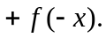

d)

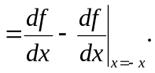

At , the terms are the same and the derivatives is zero. (See Exercise 20-2 for a situation where the derivative of f is not finite, so the string is not always horizontal at the boundary.)

